Market Basket Analysis Store Optimization

Dataset Overview
The dataset used in this project is the Online Retail Dataset, commonly available on Kaggle.
It contains real transactional sales data from a UK-based online gift store.

Key Columns:
invoice_no – Unique ID for each transaction
stock_code – Product code
description – Product name
quantity – Number of units purchased
invoice_date – Date and time of purchase
unit_price – Price per item
customer_id – Unique ID of customer
country – Customer’s country
total_price – (quantity × unit_price) (created during cleaning)

Python Work
Python was used for data cleaning, feature engineering, and exploratory analysis (EDA).
Below is a simple explanation of what was done.

- Loading the Dataset
We imported the dataset using Pandas:
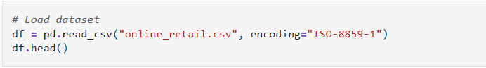

- Data Cleaning Steps
Cleaning was done carefully to ensure accurate analysis.
Here are the steps explained in short, simple points:
- Removed rows with missing values and duplicate values
Some entries had empty customer IDs or descriptions.
These were removed to avoid incorrect grouping.
- Removed cancelled transactions
Invoices starting with “C” are cancelled orders.
We dropped them because they negatively affect quantity and revenue.
- Removed negative quantities
Negative quantities usually indicate returns, so they were removed.
- Convert Datatypes
Converted string invoice_date into a proper datetime format so we can extract Month and Year.
Also converted invoice_no and Customer_id to int
- Created total_price column
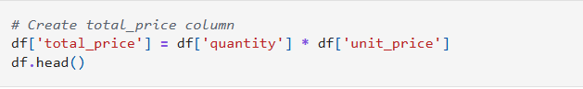
This helps in monthly revenue and product revenue analysis.

- Exploratory Data Analysis (EDA)
After cleaning, we created simple charts:
- Top 10 selling products
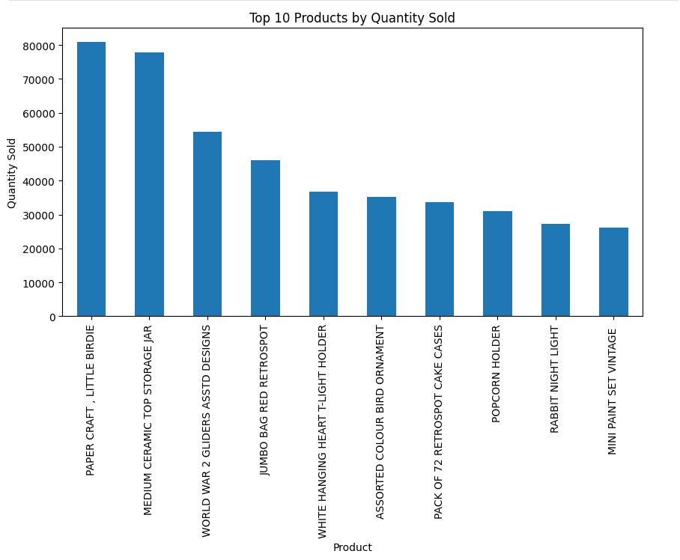
- Monthly sales trend
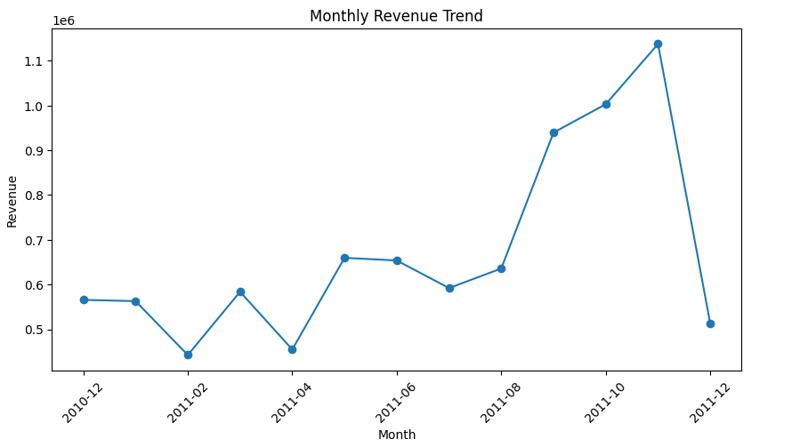

- Top countries
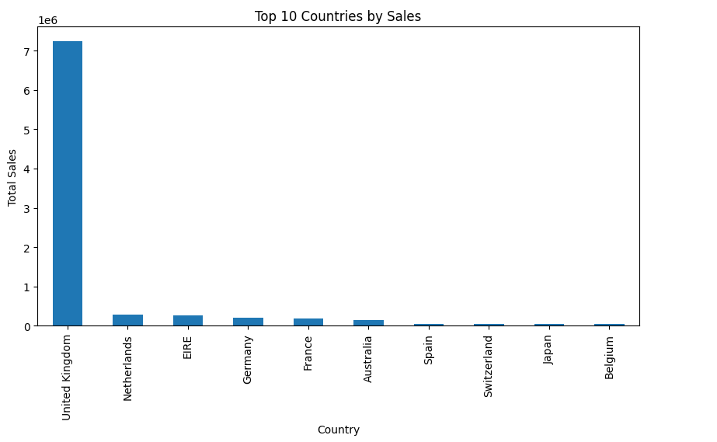
- Quantity Distribution
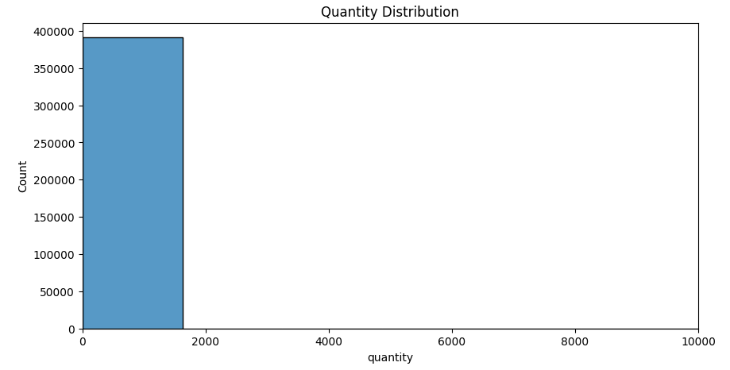
- Distribution of Unit prices
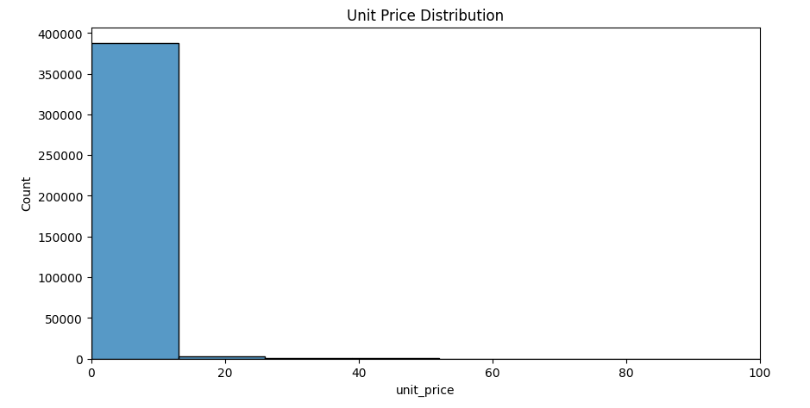
These visualizations helped understand:
- Which months sell more
- Which products are most popular
- How much customers buy in each order

- Apriori Market Basket Analysis
To find products frequently bought together, we applied the Apriori algorithm.
Because the dataset is large, we used a Top 50 most sold items approach to avoid memory errors.
Steps:
- Selected top 50 stock codes
- Created a basket matrix (invoice × stock_code)
- Converted it to True/False values
- Applied Apriori with min_support = 0.01
- Generated association rules
- Displayed top rules with highest lift
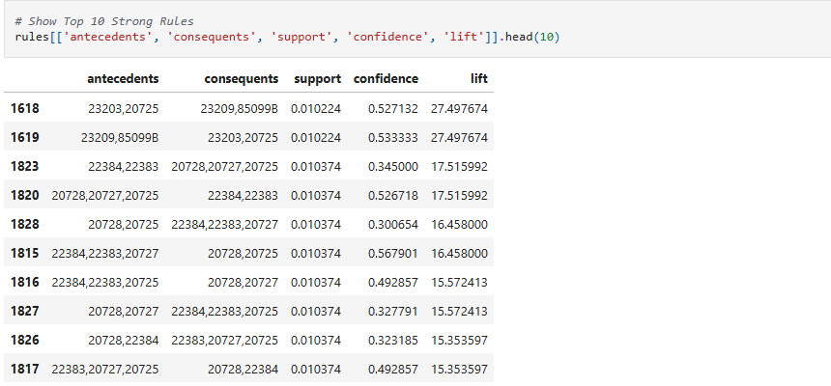
This reveals which products customers tend to buy together.

SQL Analysis
After loading cleaned data into SQL, we performed several analyses.
In SQL, we performed several important analyses on the cleaned dataset to understand customer behavior, product performance, and sales patterns.
Below are the SQL tasks and insights (without showing full code, only explanation + output meaning).

1 Top 10 Best-Selling Products
We ranked products by total quantity sold.

Insight
- A small group of top products make up a large portion of sales.
- These SKUs should be prioritized in stocking and promotions.

2 Most Active Customers
We counted how many invoices each customer generated.

Insight
- A few customers purchase very frequently.
- Helps identify loyal customers for membership, offers, or retention plans.

3 Monthly Sales Trend
We grouped total revenue by month.

Insight
- Sales show seasonal peaks in October & November.
- Indicates strong holiday season demand.
- Helps in planning inventory & marketing.

4 Most Common Products Per Invoice
Counted how many products appear together in the same invoice.

Insight
- Many invoices contain between 2–6 products.
- Customers prefer multi-item purchases, useful for bundling strategies.

5 Top Countries by Number of Customers
We counted unique customers per country.

Insight
- The United Kingdom dominates customer count.
- International customer presence is low but valuable.
- Supports decisions on regional marketing.

6 Invoices With More Than 10 Items
We filtered invoices where quantity > 10 for any product or combined.

Insight
- These are bulk orders, often linked to corporate or reseller customers.
- Helps identify high-value transactions.

7 Products Sold in the Most Countries
We counted in how many countries each product was purchased.

Insight
- Some products have broad international demand.
- These items are suitable for global expansion and export strategy.

8 Daily Sales Count
We counted number of invoices per day.

Insight
- Shows daily traffic patterns.
- Helps identify busy vs. slow days for pricing, staffing, and restocking decisions.

9 Basket Table Creation
Combined all product stock codes for each invoice.
Insight: Helped in identifying multi-item invoice patterns.

10 Simple Co-Occurrence
Checked invoices with more than one item.
Insight: Most customers buy multiple items per transaction.

11 Support–Confidence–Lift (for items 37444A & 85099B)
We measured:
- how often item A appears
- how often item B appears
- how often A & B appear together
- what is the confidence & lift
Insight: Shows whether these two items should be bundled.

12 Stock Optimization
Listed fast-moving and slow-moving products.
Insight: Helps in inventory planning & shelf placement.

Power BI Dashboard
A complete Power BI dashboard was created with:

KPIs
- Average Revenue
- Total Quantity
- Total Price
- Unit Price

Charts
- Monthly Trend Line Chart
- Revenue by Country Map Chart
- Top 10 Products Column Chart
- Quantity by Month Column Chart
- Filters (Year, Month, Country, Products)

Insight
- Sales spike in the holiday season
- UK has maximum customers
- Revenue is influenced by a small group of high-performing items

Final Dashboard

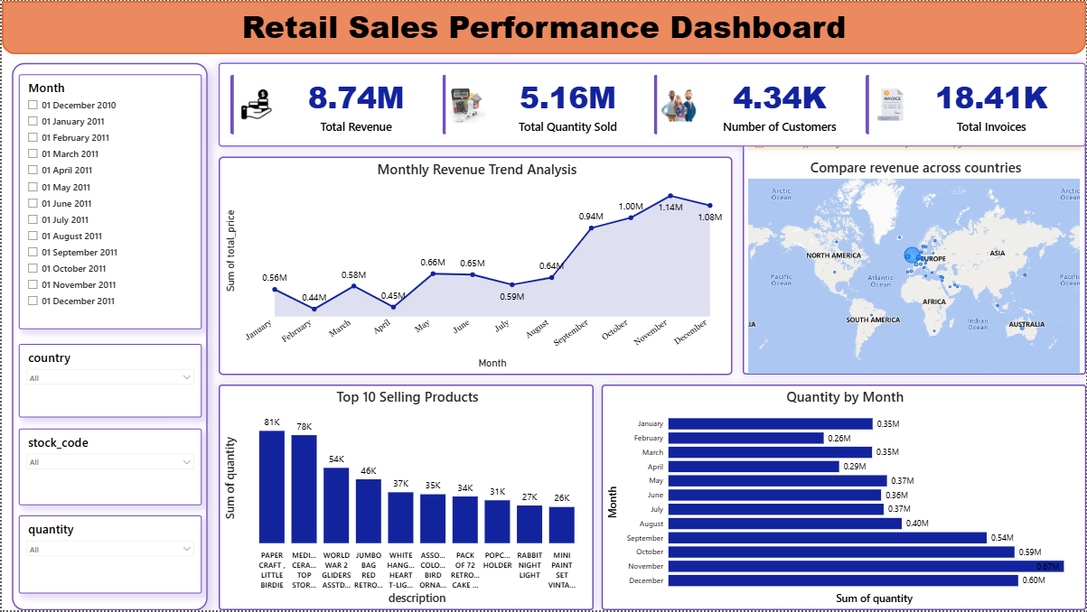

Conclusion
This project successfully demonstrated a complete data analytics workflow:
- Python for cleaning, analysis, and market basket modeling
- SQL for structured queries and business insights
- Power BI for visualization and reporting
The analysis revealed buying trends, product performance, customer behavior, and bundle opportunities.
This helps businesses in:
- Improving inventory planning
- Boosting sales using product bundles
- Identifying loyal customers
- Understanding seasonal trends

Submitted By:
- Athulraj mc
- Abhishek Singh
- Aakash
- Md Ashif

